2a. UML diagram

Slide1

Login System

-log in site. Let you enter your new school email and password.

If your details are correct then it will let you get in the system

-secure user authentication with password

-Two factor authentication for enchanted security

Admin permission

-Role-based access control for administrators

-admin can add, edit, update the data

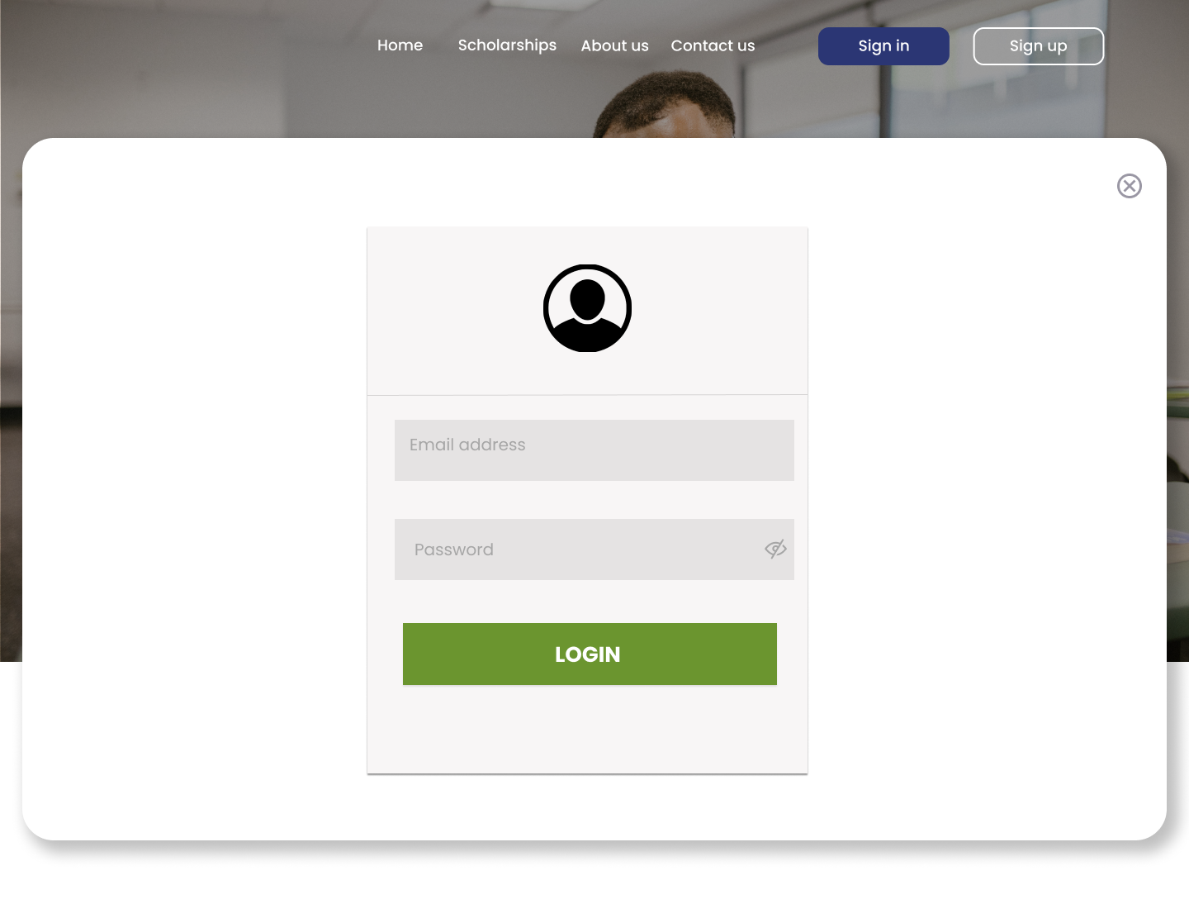

Slide2

Step tracker

* Markbook
* After successfully log in you will be taken straight to the ‘markbook’.
* Also, there are other options in the menu on the left of the screen.
* The user can select a group, subject, or curriculum by using the drop-down menu, then click Load Markbook to populate the data.

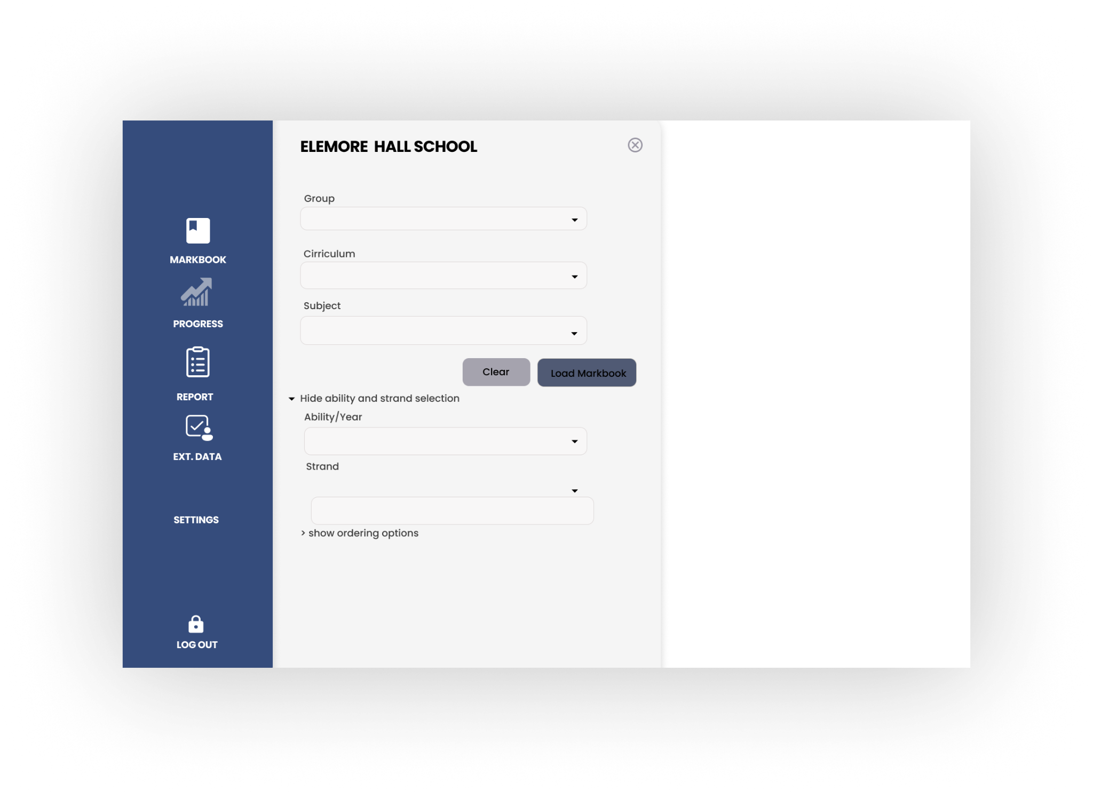

Slide3 Markbook view

* Now will be in your subject specific Markbook for an individual class group.
* Pupils name at the top and the step statements down the left hand side.
* If there have been no entries it will show that all statements are unassessed ‘U’.

Identify step statements

* Clicking on arrows and an additional column will display step statements corresponding to each entry.

Update Progress

* To update, clicking on the specific box to append.
* Multiple entries can be made quickly by dragging the mouse.

Change tile

* Click the tile in the top left corner to change it.
* It will save automatically, recording the date of the change to show ongoing progression (That is why it will be important to regularly update the scores in future. )

Assessment sheet

* The assessment sheet and it goes top to bottom. You must scroll down for higher steps.

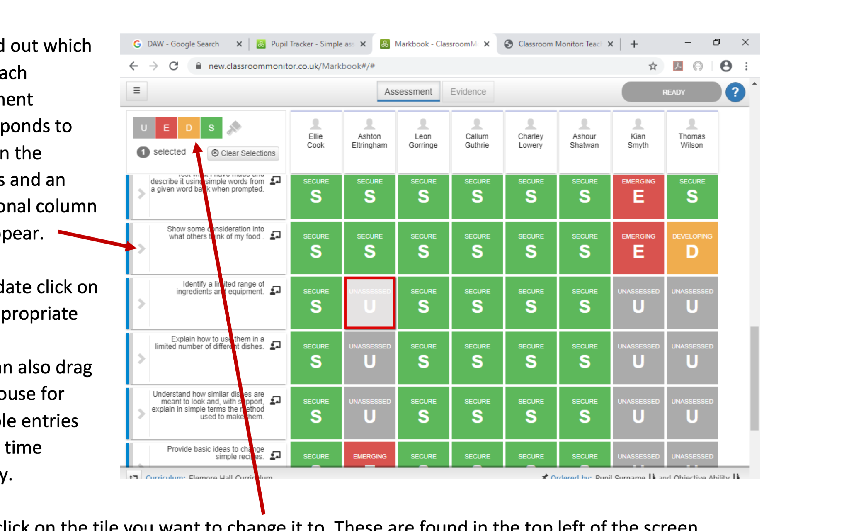

Step tracker

Input: Steps Judgments (Pressing Tiles N, E, D, S)

* Teachers input Steps Judgments by pressing tiles (N, E, D, S) in the Markbook interface.

Processing:

* The system processes the input and stores the judgments associated with each student for the selected step statement.

Slide4 score criteria

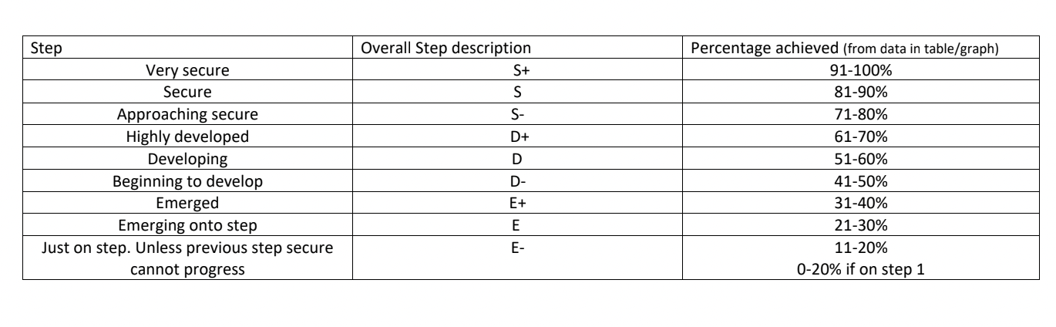

Slide5 Steps Evidence

Input: Steps Evidence

* Admin upload or input evidence of work for selected Steps statements.

Processing:

* 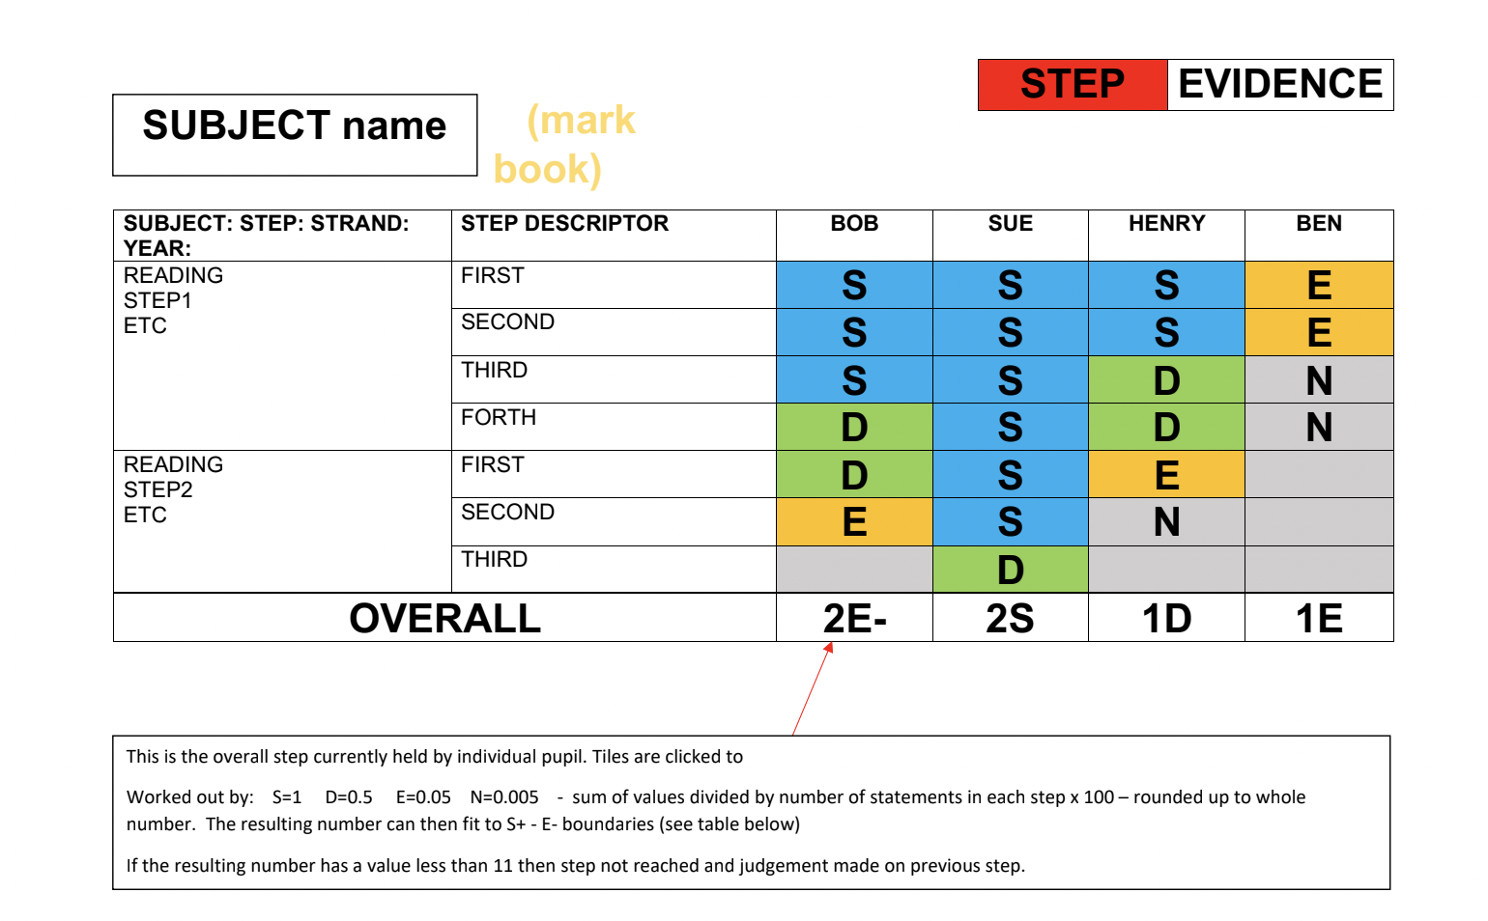The system processes the evidence and associates it with the corresponding Steps statements.

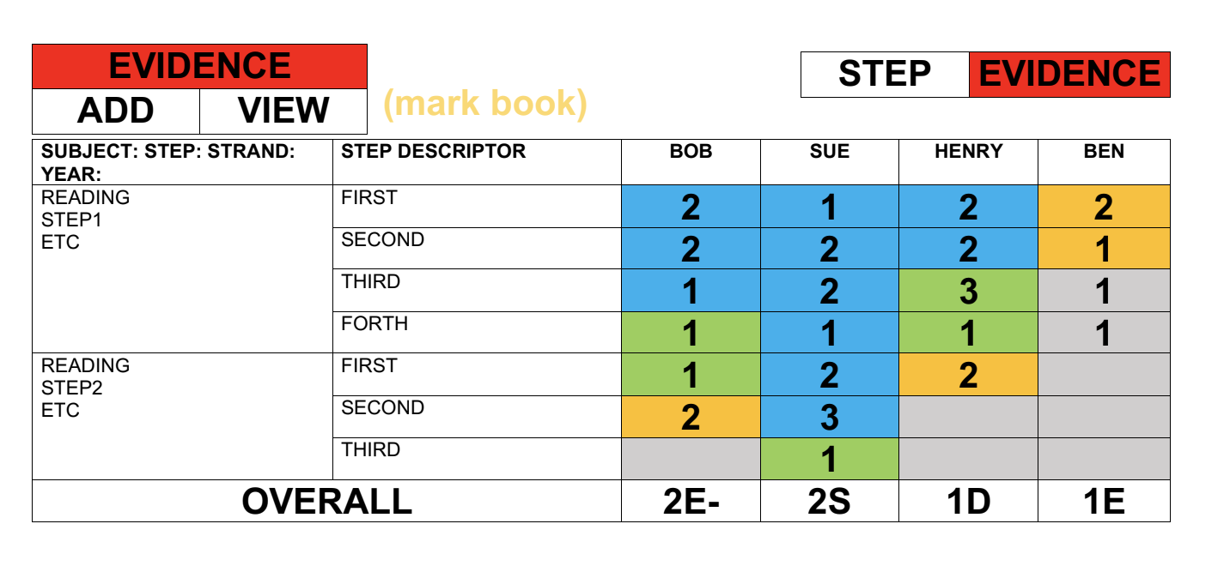

slide6

Literacy/Numeracy Tracker

The literacy & numeracy table is primarily data base – one page.

Will include all 5 years for each pupil. Also ability to add pupils who are ‘LAC’ and ‘PP’ (coloured tiles)

* Tracking and visualizing literacy and numeracy skills.
* Individualized tracking for each student.
* The Numeric Tracker operates separately from the Steps Tracker.
* Values can be entered without influencing other tasks.

Raw Value Entry:

* + Values are entered in raw form without performing additional tasks.
  + Flexibility in data entry without constraints.
  + Each class group has a separate sheet for numeric tracking.
  + Facilitates easy access and printing for specific class groups.
  + Consider using intake year or class group data from the School Information Management System (SIMS).
  + Enables the school to maintain up-to-date records